# France DA

## Database as a whole

The FRDA database consists of data collected from France GP offices for all ages. There are roughly 1109 GPs part of the database. There are about 8 million total patients in the database, with 5 million active patients. Data includes drugs, conditions, observations, measurements by the GP. Additionally, the GP could send referrals for exams or specialists to the patients which is recorded in the data. Here is a look at distribution of the database:

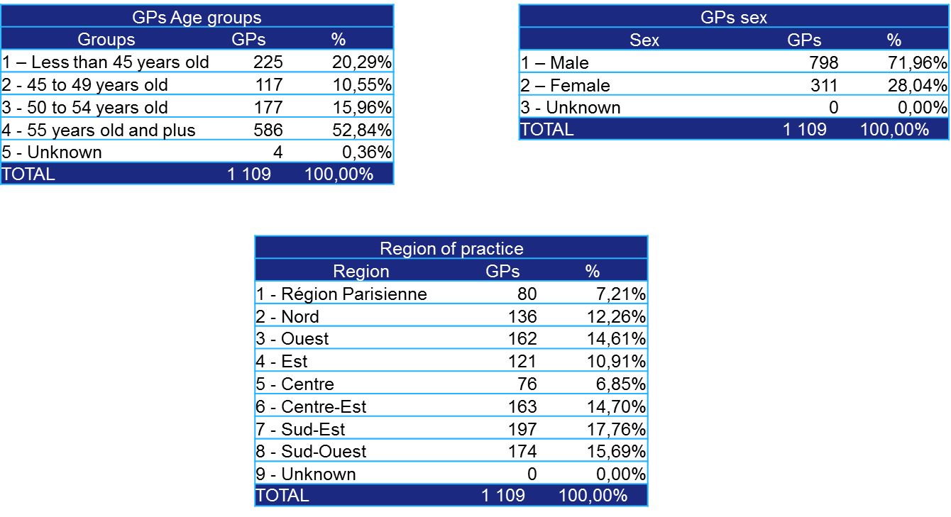

Below is a look at the data tables within France DA:

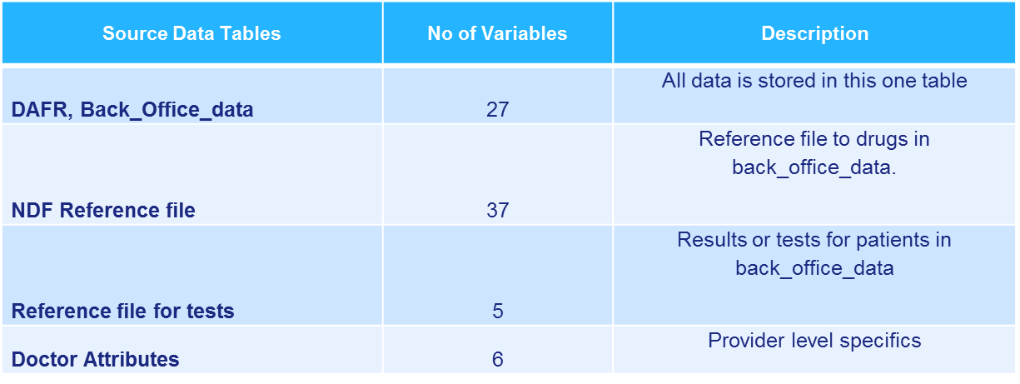

## Person

FRDA covers all age groups. Distribution is given above. In general, the year of birth is exact and the month and day are both programmed to be the 1st.

## Visit

All visits are office visits. Visits are being calculated by the event dates from CDM tables.

## Observation Period

The observation period is defined as the first and last encounter a patient has in the CDM. For this, it is being calculated from event tables in CDM.

## Location

The provinces are being recorded here. These are the locations of the GPs.

## Care Site

There are only office care sites, however other care sites such as “telephone” and “email” are recorded in this table.

## Condition

The condition occurrence is populated by recorded CIM10 codes which are ICD10 codes for diagnoses. Some of these codes could be procedure or observation domains and have been moved accordingly.

## Death

There is no death in FRDA data.

## Procedure

Procedures are being recorded from CIM10 codes or ATC codes that have a domain of procedure. There is no procedural data in FRDA as such.

## Measurement

Contains various measurement and vitals taken by the GP office. Some of this could be patient recorded, but there is little to no way to find this information out.

## Observation

The observations contain any records with a domain of observations or records that are unmapped.

## Provider

All providers are GPs. There are no provider specialties.

## Drug

Drug exposures include a mix of prescriptions and vaccination records. All vaccination records are given type concept of “physician administered”.

## Cohort

-

# German DA

## Database as a whole

The GEDA database consists of data collected from various German specialties office and dated back to 1992. In Germany, patients have direct access to specialties, and free physician choice. However, tere are privacy issues around the data. Only the date of birth can be shown for the patient and they are de-identified by a unique patient id number. The location of the physician cannot be given in the data, and thus is limited to East or West Germany. Below is a distribution of specialties in Germany:

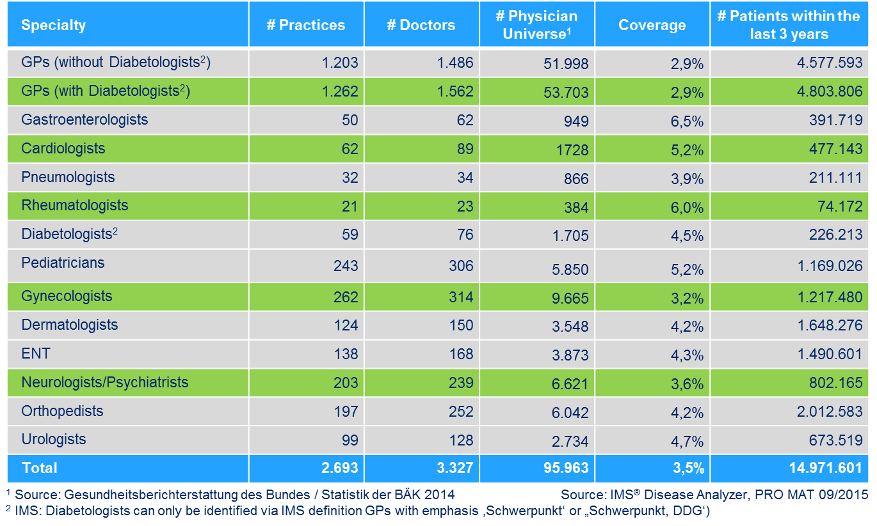

Within the data, physicians have recorded a patient’s condition, prescription history, measurements, any referrals or notes, procedures, and observations. Additionally, there is a field called “diagnosis certainty” which informs how certain the physician is about a certain condition. This field is used throughout the analysis of German DA OMOP.

Below is a look at the data tables within German DA.

|  |  |  |
| --- | --- | --- |
| **Source Data Tables** | **No of Variables** | **Description** |
| **DAFR, Back_Office_data** | 27 | All data is stored in this one table |
| **NDF Reference file** | 37 | Reference file to drugs in back_office_data. |
| **Reference file for tests** | 5 | Results or tests for patients in back_office_data |
| **Doctor Attributes** | 6 | Provider level specifics |

## Person

GEDA covers all age groups. In general, the year of birth is only given for patient’s privacy.

## Visit

All visits are office visits. Visits are being calculated by the event dates from CDM tables.

## Observation Period

The observation period is defined as the first and last encounter a patient has in the CDM. For this, it is being calculated from event tables in CDM.

## Location

Due to privacy reasons, only East and West Germany are given as locations.

## Care Site

There are only office care sites in the data.

## Condition

The condition occurrence is populated by recording the ICD10 codes in the data. Also, when diagnosis_certainty field = Confirmed, then only is a record populated in condition occurrence. This field explains how confident the physician is that a patient has a diagnosis, and only confirmed diagnoses should be counted as one’s the patient actually has.

## Death

Death information is being populated by ICD10 death codes indicated by business. These death codes have to have a diagnosis certainty of confirmed. Also, if a patient has any activity after death date, the patient is considered alive and their events are recorded in respective CDM tables.

## Procedure

Procedures are being recorded from ICD10 codes and also some from drug codes. All of these codes have a domain = procedure.

## Measurement

Contains various measurement and vitals taken by the physician. This can be patient reported as well, but there is no way to find this information out.

## Observation

The observations contain any records with a domain of observations or records that are unmapped.

## Provider

There are provider specialties within the data, as well as GPs. In Germany, a provider can also focus on a specialty, such cases, the provider is mapped to respective specialty.

## Drug

Drug exposures include a mix of prescriptions and vaccination records. All vaccination records are given type concept of “physician administered”.

## Cohort

-

# Australia LPD

## Database as a whole

The AU LPD database consists of data collected from GP offices for all ages. There are roughly 900 GPs part of the database. There are about 1.6 million total patients in the database. Data includes drugs, conditions, observations, measurements by the GP. Below is a look the patient and practice counts for all three datasets:

|  |  |  |  |
| --- | --- | --- | --- |
|  | **GERMANY** | **FRANCE** | **AUSTRALIA** |
| **Patients** | 29.3 m | 4.0 m | 1.6 m |
| **Practices\*** | 2517 | 1118 | 700 or 900 |
| **Available since** | 2009 | 2009 | 2009 |

Data Source: Disease Analyzer 2016

*Office based GPs and specialists in Germany and Canada; GPs only in France and Australia

The data is recorded from EMR software similar to Germany and France. LPD stands for Longitudinal Patient Data, and means a patient can be traced back in history longitudinally with the data provided by the doctor.

## Person

All patients recorded have a YOB. However, there are patients with YOB less than year of 1900. Also, month of birth was provided by data.

## Visit

All visits are office visits. Visits are being calculated by the event dates from CDM tables.

## Observation Period

The observation period is defined as the first and last encounter a patient has in the CDM. For this, it is being calculated from event tables in CDM.

## Location

Distinct practice post codes are recorded.

## Care Site

All place of service within care site is office. The location ids from location table are linked to care site table.

## Condition

All diagnosis codes which are ICD10 are being recorded within condition. Majority of these records are in the contact table. Also, there are some records in prescription table which have a domain of condition, these records are added to condition occurrence. Allergies are recorded in source data, and majority of them are populated within conditions.

## Death

Death flag is given in source data, all records are being added for patients with this death flag.

## Procedure

Procedure data is being recorded from contact table which would tell us if a diagnosis code has a domain of procedure. Also, procedures related to allergies and/or prescriptions are being populated here if domain = procedures.

## Measurement

Contains various measurement and vitals taken by the physician. This can be patient reported as well, but there is no way to find this information out.

## Observation

The observations contain any records with a domain of observations or records that are unmapped.

## Provider

All providers are GPs. There are no provider specialties, but there are nurse practitioner, these have been added to specialty field.

## Drug

All prescription and immunization information is being retained within drug exposure.

## Cohort

-